Problem 4:

Realize the filter described by difference equation

𝐲(𝐧) = 𝟎.𝟓 ∗ 𝐲(𝐧 − 𝟏) − 𝟎.𝟐𝟓 ∗ 𝐲(𝐧 − 𝟐) + 𝐱(𝐧) + 𝟎.𝟒 ∗ 𝐱(𝐧 − 𝟏)

Solution:

Pen-paper work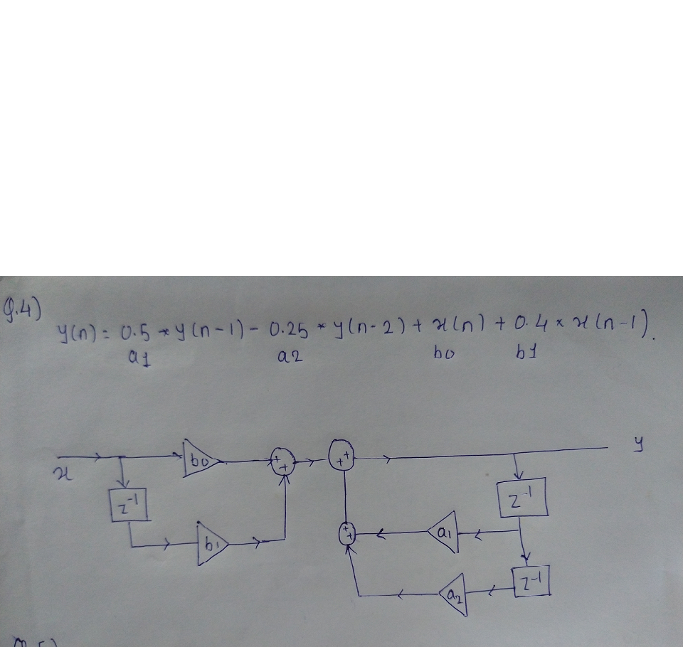

Output :

